
MATCH CONFIRMATION
DATE: | DD/MM/YYYY | VENUE: | Virginia Water FC  The Timbers  Crown Road  Virginia Water  GU25 4HS
FIXTURE: | VWFC vs XX
COMPETITION: | Surrey Primary League
KICK OFF: | HH:MM am/pm
PITCH: | 5 a-side / Back Pitch / Main Pitch
     | 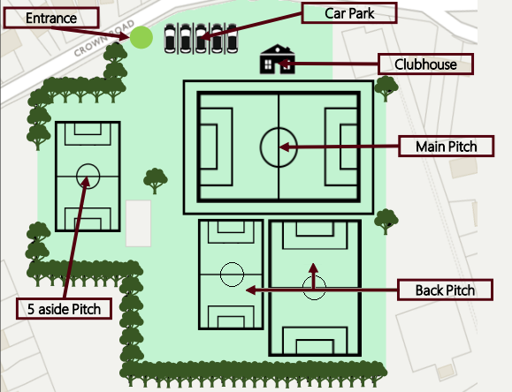
CONTACT: | Yours or Coaches Name
The clubhouse will be open for refreshments
We look forward to welcoming you on the DD/MM/YYYY
Directions
From the M25, exit at Junction 11 onto the A320 (St Peter’s Way). At the first roundabout, take the 3rd exit onto the A320 (Guildford Road) to the second roundabout. Then take the first exit into Holloway Hill and immediately turn right into Hardwick Lane. Follow this road for approximately three miles to the T junction. Turn left onto Trumpsgreen Road. Go under the railway arch, past the shops on the right, and Crown Road is the next turning on the right. The entrance to the ground is approximately 500 yards on the left.
From the A30, opposite The Wheatsheaf PH at Virginia Water lake, turn into Christchurch Road. At the first roundabout take the third exit onto Wellington Avenue. Crown Road is approximately one mile on the left hand side. The entrance to the ground is 150 yards on the right.
Kind Regards | Your Name | Tel: | Your Number
Maroon Shirt, Shorts & Socks

